LAB 4

**Task 1**

Use **while** loop to print “**Welcome to City University”** 5 times?

**Task 2**

Use **while** loop to print first 10 integers with tab space?

**Task 3**

Modify task 2? Write program that takes an integer input & display number till that integer?

**Task 4**

Write program using **while** Loop and display following result

**Number Square Cube**

1 1 1

2 4 16

3 9 27

4 16 64

5 25 125

6 36 216

**Task 5**

Write a program using **while** loop that prints even number (from number 0-100)

**Task 5a**

Modify program in task-5 and print first 50 odd numbers separately and even numbers separately?

**Task 6**

Modify task 5 and produce sum of first 50 odd numbers from(0-100) and also produce sum of first 50 even numbers(0-100)?

**Task 7**

Write a program that generate table of 2 using while loop?

**Task 8**

Modify Task 7 take input from user and generate table for number user has requested?

**Task 9**

Modify task 8 take two inputs from user one for table & one for multiple of table and produce results?

**Task 10**

Write program that produce first 10 integers in descending order?

**Task 11**

Modify task10 to produce factorial of a number entered by user?

**Task 12**

Write a program that product following result

**+*+*+*+*+*+*+*+*+*+*+\***

**Task 13**

Write a program that product following result

1 2 3 4

5 6 7 8

910 11 12

13 14 15 16

**Task 14**

Write a program that produce following result

**\*\*\*\*\*\***

**\*\*\*\*\*\***

**\*\*\*\*\*\***

**\*\*\*\*\*\***

***Hint: Use nested while loop to complete structure?***

**Task 15**

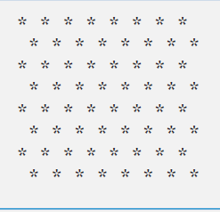Write a program that product following result

***********

***********

***********

***********

***********

***********

***Hint: Use nested while loop to complete structure?***

**Task 16**

Write a program that product following result

***Hint: Use nested while loop to complete structure?***

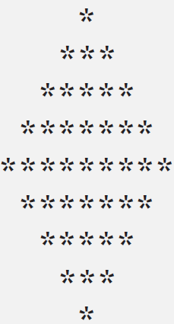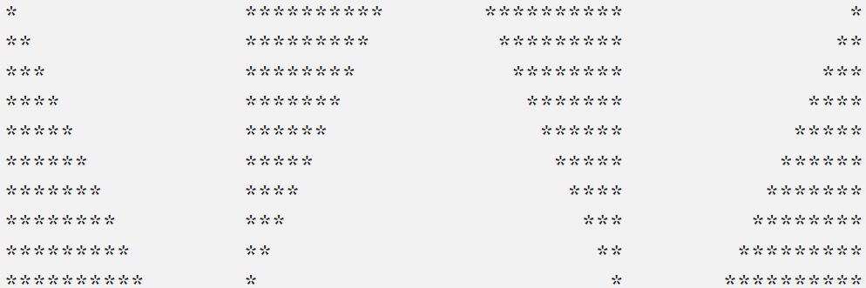

**Task 17**

Write a program that product following result

***Hint: Use nested while loop to complete structure?***

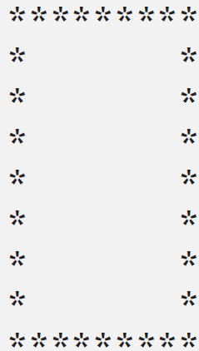

**Task 17**

Write a program that product following result

***Hint: Use nested while loop to complete structure?***